**We can select any package folder of java tile to convert into TestNG:** Here converting the “root” package into “TestNG”

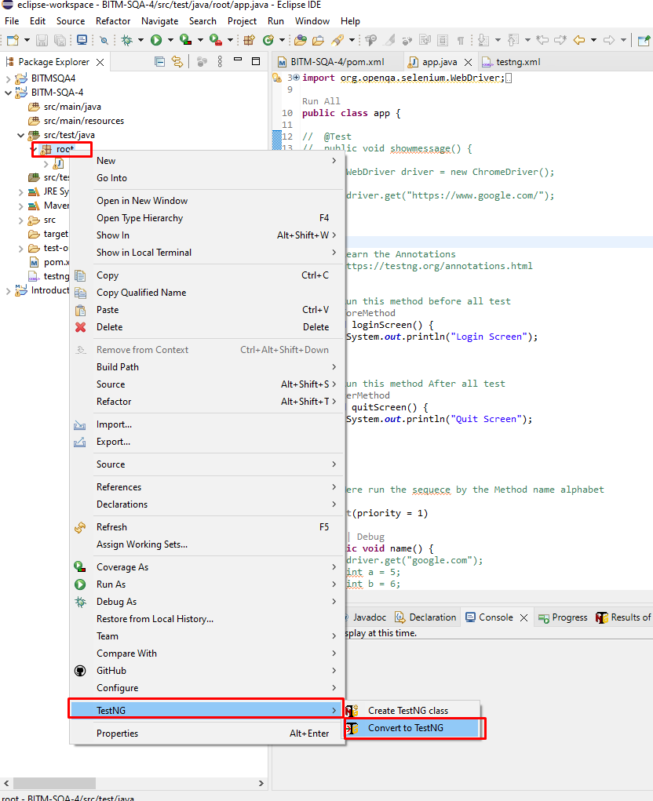

**Create a New Maven Project to run Selenium and TestNG:**

<https://www.youtube.com/watch?v=hQmMmKQ_hbs>

**Step 1:**

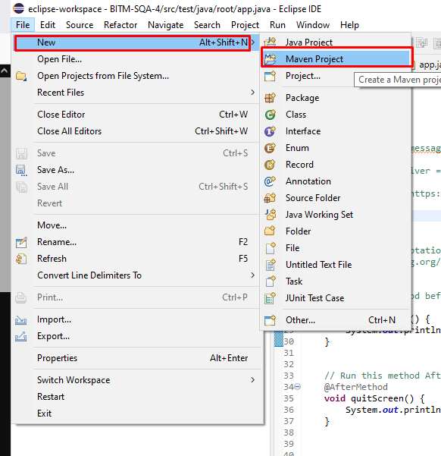

**Step 2:** Select “Create a simple project”

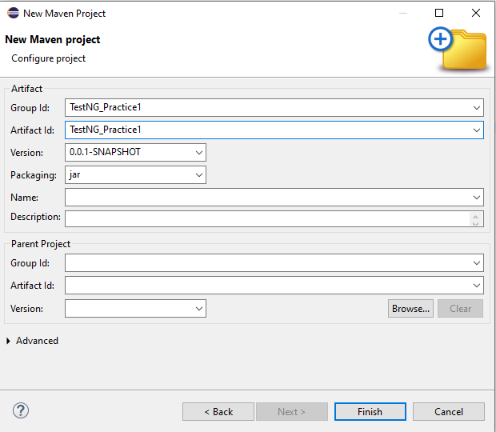

**Inside the “src/test/java” folder we will create package and java class for making our test cases.**

Now we can convert the whole “TestNG_Project” file into “TestNG” which makes a file called “tesng.xml”